 

**FI6032 – CREDIT RISK AND DERIVATIVE PRODUCTS**

**30% TECHNICAL REPORT**

**TITLE :**

***QUANTITATIVE RESEARCH AND CURVE TRADING STRATEGY SIMULATION ON CREDIT CURVES TAB***

BY:

|  |  |
| --- | --- |
| **NAME** | AKHIL MENON |
| **STUDENT ID** | 19008414 |
| **COURSE** | MSc – COMPUTATIONAL FINANCE |

**INTRODUCTION**

The objective of this report is to apply curve trading strategies utilising quantitative research skills over a credit risk dataset in order to exploit potential trading arbitrage opportunities through these instruments.

**TRADING STRATEGIES:**

1. **A 5s10s DV01-Neutral Flattener:**

**Entity Description**

The entity to be traded in the steepener curve trade strategy is the “CI674 CDX IG”. It is the Markit CDX North American Investment Grade Index, that comprises of 125 credit default swaps (CDS) on investment grade entities and the 125 credit default swaps are equally weighted. These CDS’s are distributed among the multiple sub-indices, namely: Financial, High Volatility, Industrial, Consumer, Technology, Media & Telecommunications and Energy. These credit curve indices roll out every six months, in the months of March and September every year.

**Trade Rationale:**

As of 18th February 2020, the CDS curve of the 5s10s CDX IG was found to be steep (see figure 1). With the credit curve covering industries such as Financial, Industrial, Consumer and Energy, there was expectations of these sectors to be affected by the COVID-19 Pandemic and hence an expectation of curve flattening is foreseeable in the near short-term future. Hence, to capture this flattening expectation, a 5s10s DV01-Neutral Flattener trade on the CDX IG is performed

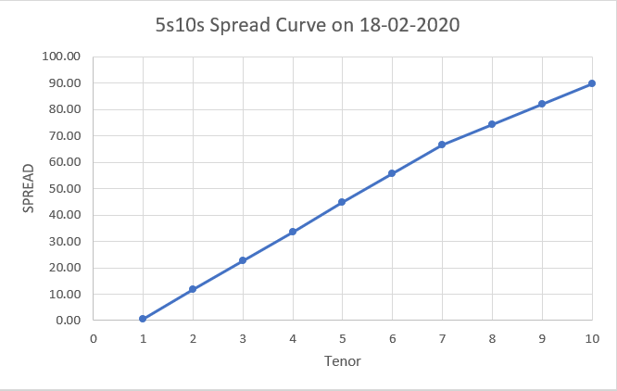

**Figure 1: 5s10s Spread Curve on 18th February 2020**

**Trade:**

To perform the 5s10s DV01-Neutral Flattener trade, we will go long on the 5 year protection of the CDX IG and go short on the 10 year protection of the CDX IG. Since it is a DV01-Neutral curve trade, the notional amount for the positions are based on the hedge ratios.

|  |  |
| --- | --- |
|  | CDS Spreads |
| 5Y DV01 | 4.85 |
| 10Y DV01 | 8.98 |
| Hedge Ratio | 1.85 |
| 5Y Long Protection Notional | 18.5 Million |
| 10Y Short Protection Notional | 10 Million |

**Table 1: Hedge Ratio for 5s10s CDX IG Spreads**

**Trade Analysis & Evaluation:**

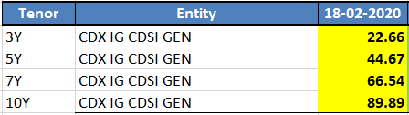

**Figure 2: CDS Spreads of CDX IG for Tenors = 3Y, 5Y, 7Y & 10Y on 18th February 2020**

With the CDS Spread values for other Tenors for the CDX IG Credit curve, a linear interpolation is performed to obtain these values. Following is the values obtained upon interpolation:

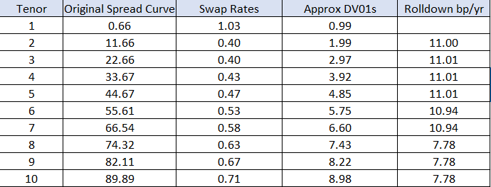

**Figure 3: CDS Spreads, Approx DV01, Rolldown of CDX IG for tenors = 1-10 Years on 18th February 2020**

The swap rates utilised are from the US Swap Rates Act/360 Curve obtained through Bloomberg. Upon analysing the data prior to trading, the following drivers of the Profit & Loss i.e the Carry and the Rolldown of the trade were found to be $ 1206.93 and - $ 4,460.03 respectively.

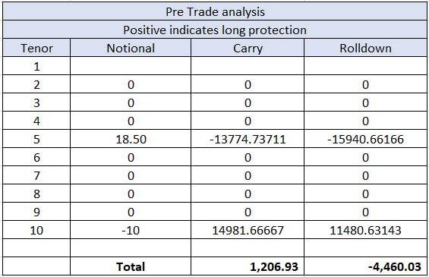

**Figure 4: Pre-Trading Analysis Statistics of 5s10s Curve Trade**

With the 5Y spread increasing at the same rate as the 10Y Spread over the trading horizon, gains were able to be captured through the Flattener trade. We were able to exit the trade with major profits on 15th April 2020.

**PROFIT & LOSS CALCULATION:**

* **Trade Entry Date: 18/02/2020**
* **Trade Exit Date: 15/04/2020**
* **Horizon = 2 Months**
* **Carry = $ 1206.93**
* **Total Mark to Market Position = $ 165,173.55**

**Profit & Loss = Total Mark to Market + Carry**

= $ 165,173.55 + $ 1206.93

= **$ 166,380.48**

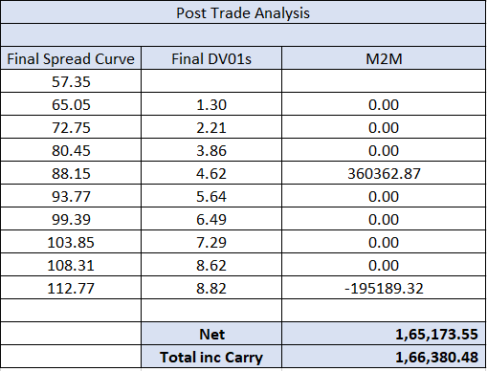

**Figure 5: Post-Trade Analysis Statistics of 5s10s Curve Trade**

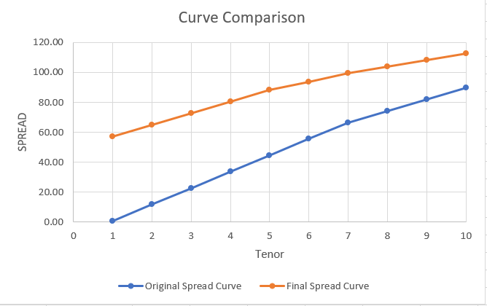

**Figure 6: Curve Comparison- Curve Spread on 18/02/2020 vs 15/04/2020**

1. **A 7s10s DV01-Neutral Steepener:**

**Entity Description**

The entity to be traded in the flattener curve trade strategy is the “CD1442 Deutsche Lufthansa AG”. It is the single-name corporate bond of the German Airline Carrier company Deutsche Lufthansa AG.

**Trade Rationale:**

On March 11th, 2020, the 7s10s CDS spread curve of Deutsche Lufthansa AG (see Figure 7) appeared to be flat and with the coronavirus pandemic in the initial stages of affecting Germany, the main operational base of the company, it was likely to expect movements in the CDS spread and there were expectations of temporary provisions to completely halt the company’s operations, similar to the company’s counterpart airline carriers in the Asian region. In order to capitalise this potental view, a 7s10s DV01-Neutral Steepener trade is performed on the Deutsche Lufthansa AG single-name corporate CDS.

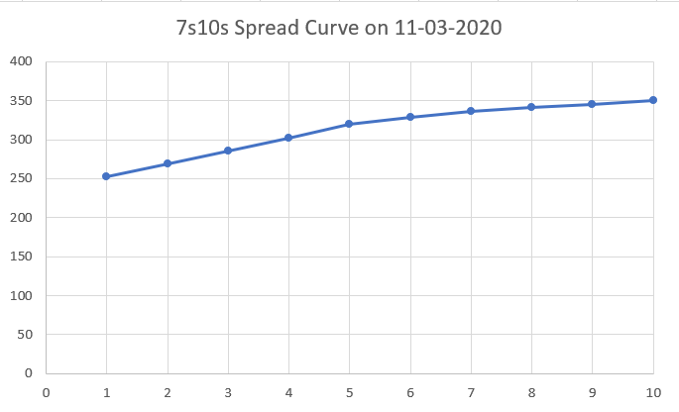

**Figure 7: 7s10s Spread Curve on 11th March 2020**

**Trade:**

To perform the 7s10s DV01-Neutral Steepener Trade, we will go short on the 7 year protection of the Deutsche Lufthansa AG CDS and go long on the 10 year protection of the Deutsche Lufthansa AG CDS. Once again, since it is a DV01-Neutral curve trade, the notional amount on these positions are determined by calculating the hedge ratios.

|  |  |
| --- | --- |
|  | CDS Spreads |
| 7Y DV01 | 5.68 |
| 10Y DV01 | 7.34 |
| Hedge Ratio | 1.2923 |
| 7Y Short Protection Notional | 12.923 Million |
| 10y Long Protection Notional | 10 Million |

**Table 2: Hedge Ratios for 7s10s Deutsche Lufthansa AG CDS Spreads**

**Trade Analysis & Evaluation:**

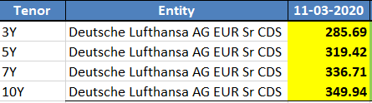

**Figure 8: CDS Spreads of Deutsche Lufthansa AG for Tenors = 3Y, 5Y, 7Y & 10Y on 11th March 2020**

Due to the unavailability of the CDS spread values for other tenors, the remaining values were obtained through the process of linear interpolation. Upon interpolation, the following data was obtained:

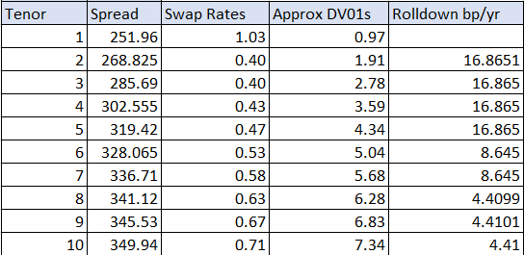

**Figure 9: CDS Spreads, Approx DV01, Rolldown of Deutsche Lufthanas AG for Tenors 1-10 Years on 11th March 2020**

The swap rates utilised are from the US Swap Rates Act/360 Curve obtained through Bloomberg. Upon analysing the data prior to trading, the following drivers of the Profit & Loss i.e the Carry and the Rolldown of the trade were found to be $7101.37 and $2557.57 respectively.

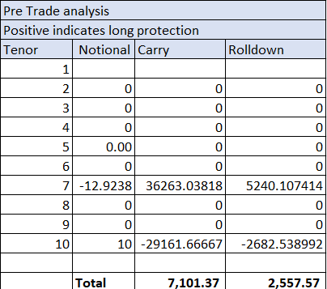

**Figure 10: Pre-Trading Analysis statistics of 7s10s trade**

Until the 24th of March, the curve seemed to be steepening as expected, but following which, there was a drop both in the 7y and 10y CDS spread values which also followed with a flat movement of the CDS Curve going against our expected view. But eventually the CDS curve recovered and the curve begin to steepen slightly, and we were able to exit the trade profitably on 15th April 2020.

**PROFIT & LOSS CALCULATION:**

* **Trade Entry Date: 11/03/2020**
* **Trade Exit Date: 15/04/2020**
* **Horizon = 1 Month**
* **Carry = $ 7101.37**
* **Total Mark to Market Position = $ 10,364.80**

**Profit & Loss = Total Mark to Market + Carry**

= $ 7101.37 + $ 10,364.80

= **$ 17,466.17**

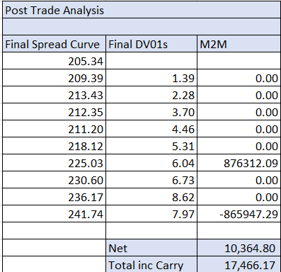

**Figure 11: Post-Trade Analysis Statistics of 7s10s Curve Trade**

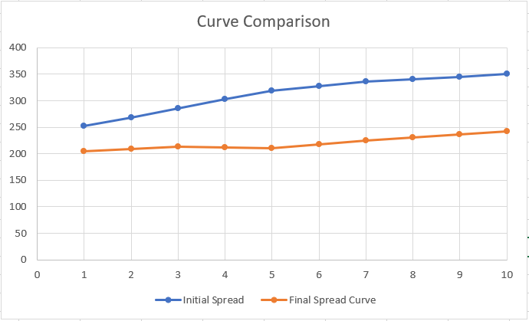

**Figure 12: Curve Comparison: Curve Spread on 11/03/2020 vs 15/04/2020**

**CONCLUSION**

Through research and judgement of market environment and forecasts, two trading strategies were applied on the CDX IG and Deutsche Lufthansa AG credit curves over a 2-month and 1-month horizon, with both strategies gaining profitability by the trade exit period.

**BIBLIOGRAPHY:**

Barclays Capital (2008) *CDS Curve Trading Handbook 2008: Quantitative Credit Strategy*.

Barclays Capital (2010) *Standard Corporate CDS Handbook*.